**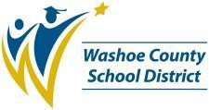****Washoe County School District**

**Grants Department Organizational Chart**

Lauren Ohlin Director of Grants

Hannah Yue

Grant Fiscal Administrator

Randy Drake Assistant Director of Grants/

Compliance

Marianne Reger

Grant Writer

Danielle Howard

Grant Coordinator

Keely Lallement

Executive Assistant

Michelle Robinson

Program Service Tech

Janett Sanchez

Grant Accountant

Melisa Villagomez

Grant Accountant

MarkMathers

Chief Financial Officer

**Joe Ernst**

**Superintendent**